Meeting Plan - 1 – Flight

6-6:10 GAMES

6:15 – Build the STOCKADE
Welcome boys – ages?
Stockade Sign - MOTTO - Bright and Keen for Christ

Spring Memory Verse - Joshua 1:9 (NLT)
⁹ This is my command—be strong and courageous! Do not be afraid or discouraged. For the Lord your God is with you wherever you go.”
Prayer Sign – PRAYER Sit

Tonight we start a unit on FLIGHT

Over the next four weeks we are going to learn how planes fly – does anyone know what that’s called?

the study of aerodynamics

Next week – we are going to go to the airport as see an actual plane

In two weeks – we’ll start building our rockets

And in week four – we’ll decorate our rockets

OUR THEME is FAITH - AND THIS WEEK WE ARE TALKING ABOUT PERSEVERANCE

Our verses for the next four weeks come from Isaiah 40: 28-31 ²⁸ Have you not known? Have you not heard? The LORD is the everlasting God, the Creator of the ends of the earth. He does not faith or grow weary; His understanding is unsearchable. He gives power to the faint, and to him who has no might He increases his strength, Even youths shall faint and be weary, and young men shall fall exhausted. But they who wait on the LORD shall renew their strength; they shall mount up with wings like eagles; they shall run and not be weary; they shall walk and not be faint.

REPEAT IT underlined for tonight.

We’ll talk more about this verse in our Post times

6:10 – GAMES – 20 min

6:30 – Post Time – 20 min

THEME: FAITH

6:50 – PROJECT – 25 min

7:15 - story time – Bill

7:25 – closing - review verses for tonight
AWARDS
IRCLE UP STOCKADE SIGN – MOTTO - PRAYER SIGN - STOCKADE PRAYER
Lord our Savior Guide and Captain, Be a solid wall around us
Make us all courageous servants, Help us to be more like Jesus. Amen.
POST RANGERS

6:30 to 6:50 Post Time

THEME: FAITH – PERSEVERENCE

Isaiah 40: 28-31 ²⁸ Have you not known? Have you not heard? The LORD is the everlasting God, the Creator of the ends of the earth. He does not faint or grow weary; His understanding is unsearchable.

TALK ABOUT Scripture Verse What do you think these verses mean?
Did YOU know? Have YOU heard? That the LORD is everlasting? What does that mean?
Did YOU know? Have YOU heard? That the LORD is …Creator of the ends of the earth? What does that mean?
Do YOU grow faint or weary? Do you get tired?
If you are doing something important – you need to persevere even if you’re tired.
Examples? Sports – homework - chores
Does God get tired?
We need to persevere in our faith. How do we do that?
Read our Bible = pray – go to church/Sunday school – not let others lead us away from God

What does …His understanding is unsearchable. Mean?
Where do you think the ends of the earth are?
How would you get there? What would you use to get there fast?

FLIGHT – pass out sheets
Can you identify all these flying machines?
Give them a chance to do it then…
Which is the fastest? Which is the slowest?
Have any of you ever flown in a plane or helicopter?

Memory Verse
Isaiah 40:31 But they who wait on the LORD shall renew their strength; they shall mount up with wings like eagles; they shall run and not be weary; they shall walk and not be faint.

6:50 – Paper Airplane Project – 25 min - SIT BY POST

6:50 – Paper Airplane Project – AERODYNAMICS - 25 min

Tonight we’re going to learn about Aerodynamics
Who can tell me what that word means?
Definition is “the study of objects moving through air”
So if we are going to learn how a plane flies – we need to know about aerodynamics.
There are four “Principles of Flight” (SHOW PLANE)
First we want to talk about what keeps an airplane flying?
So we’ll use this paper airplane (LIFT AND DROP)
Why does it fall? WEIGHT – the force of gravity on all things

So a plane has to overcome it’s weight. That’s called LIFT.
DEMO WITH BLANK PAPER – blow over it.
So by moving air OVER a surface, you can reduce the pressure on that side of the object – causing it to LIFT!
Grab a piece of paper and try blowing OVER it!

PUT PLANE ON SANDPAPER
Why is the plane not sliding off the paper? (friction) DRAG
IF there were no friction the plane would easily slide off.
Stroke your finger across your piece of paper. It’s rough.
That friction causes air to stick to it.
It also has size so it has to push air out of it’s way.
These things cause DRAG and slow the plane down.

So we need something to overcome the DRAG.
Does anyone know what that might be?
THRUST – THROW PLANE.
My arm provides THRUST – on a real plane it’s the engine.
So what are the FOUR PRINCIPLES OF FLIGHT?
Alright – are you ready to build a plane?
First, we’re going to make a DART. So grab your piece of paper and fold it in half.
Open it up and fold the corners in to the center fold
Fold the upper corners in to center again.
Now fold it in half on your original crease
Fold both sides down about 1/3 and 2/3 to make your wings.
FLY THEM

OK – let’s try another style plane
This is called a GLIDER.
Take a new sheet of paper and fold in half again
Fold the corner in to the center like last time.
NOW – fold the point to about an inch above the bottom
Fold the upper corners to the center again – above the point
Fold the point up over the previous fold
Fold in half on original fold
Fold the R & L edges to the center fold to create wings.
FLY THEM.

Ready to try an new one?
This one is called THE MIGHTY DUCK
Start the same – fold in half – open and fold in corners
Now – turn it over and fold corners to center
Unfold first fold from underneath
Fold top point to lower point
Fold top point back up just beyond fold
Fold in half – front side to front side
Fold wings about 2/3 of the way down

FLY
ADD PAPER CLIP TO BACK END
ADD ONE PAPER CLIP TO FRONT & TWO MORE BACK

THE RING
Fold one side to the other leaving about an inch on the top
Fold edge over about ½ inch
Fold again
Fold again
Fold again
Roll into a circle and tuck or tape points.
Throw by “wings”.

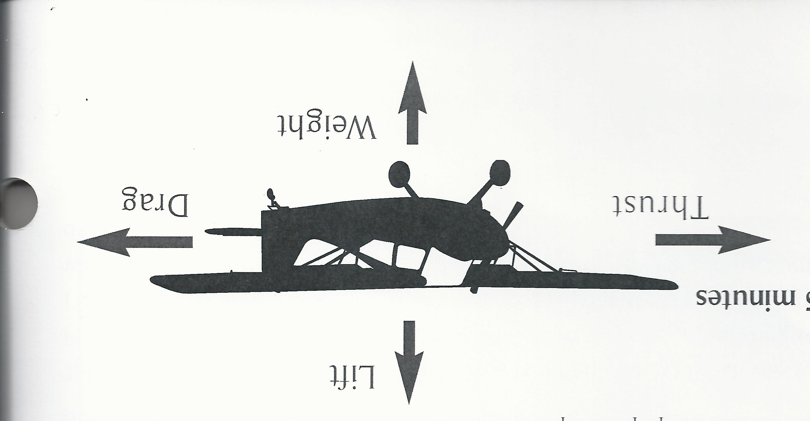

WEIGHT =

LIFT =

DRAG =

THRUST =

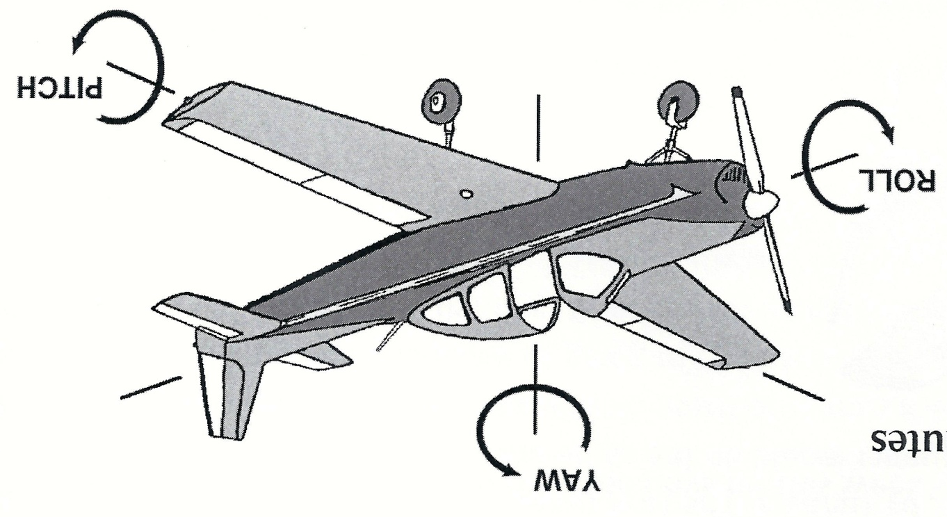

YAW =
ROLL =
PITCH =
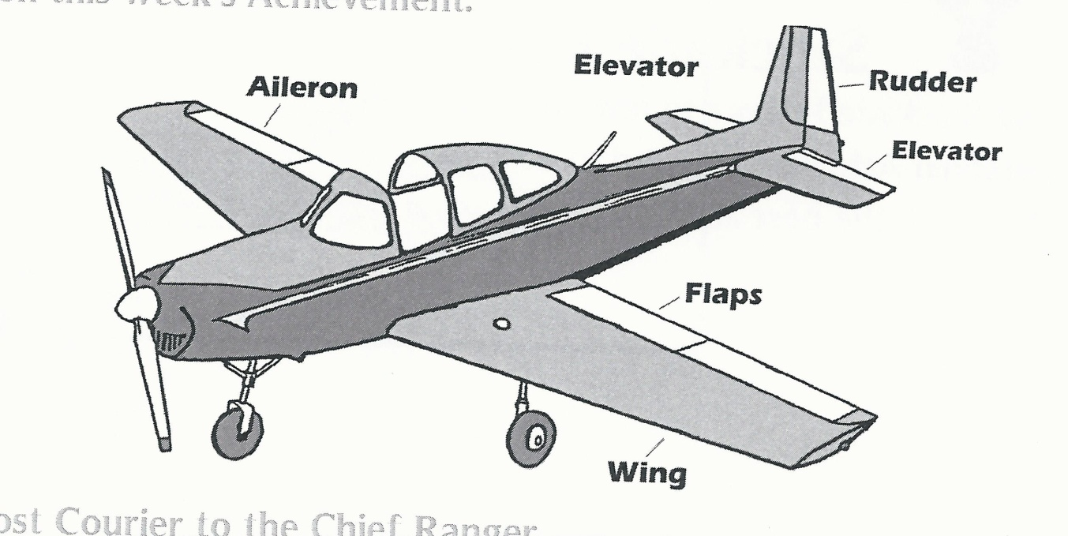
AILERON =
ELEVATOR =
FLAPS =
RUDDER =
ASSIGNMENTS for Apr 28

Work on MEMORY VERSE
Isaiah 40:31
But they who wait on the LORD shall renew their strength; they shall mount up with wings like eagles; they shall run and not be weary; they shall walk and not be faint.

Copy plane identification sheet into your FLIGHT book

Review PRINCIPLES (page 1) & Learn plane parts and what they do (page 2).

WORK ON BUILDER BADGE.

NEXT WEEK – 6PM AT AIRPORT

ASSIGNMENTS for Apr 28

Work on MEMORY VERSE
Isaiah 40:31
But they who wait on the LORD shall renew their strength; they shall mount up with wings like eagles; they shall run and not be weary; they shall walk and not be faint.

Copy plane identification sheet into your FLIGHT book

Review PRINCIPLES (page 1) & Learn plane parts and what they do (page 2).

WORK ON BUILDER BADGE.

NEXT WEEK – 6PM AT AIRPORT

ASSIGNMENTS for Apr 28

Work on MEMORY VERSE
Isaiah 40:31
But they who wait on the LORD shall renew their strength; they shall mount up with wings like eagles; they shall run and not be weary; they shall walk and not be faint.

Copy plane identification sheet into your FLIGHT book

Review PRINCIPLES (page 1) & Learn plane parts and what they do (page 2).

WORK ON BUILDER BADGE.

NEXT WEEK – 6PM AT AIRPORT

